Culture-Based Tourism Development Portal: A Digital Framework for Sustainable and Community-Driven Cultural Tourism
V. Chandrasekar, Vishal Gowda H, Rakshitha D P, Sai Siri Naidu O
Presidency University, Rajanakunte, Bengaluru, Karnataka - 560119 ,India.
Springer Heidelberg, Tiergartenstr. 17, 69121 Heidelberg, Germany
lncs@springer.com
Abstract

Tourism has currently taken a more cultural perspective of what one may receive as opposed to sightseeing. The existing digital tourism systems have been created to support travel-related booking and logistics services. They do not give much opportunities in terms of cultural interaction or any community involvement. The paper presents the Culture-Based Tourism Development Portal, a web-based program of promoting cultural heritage through sustainable tourism by use of digital innovation. It combines tourists, domestic artisans and tourism boards into a single digital ecosystem. It is written in HTML, CSS, JavaScript, PHP, MySQL with the integration of Google Maps and Event APIs to provide real-time information on cultural destinations and activities, it provides personalized recommendations about culture to select based on a con-tent based recommendation model. Moreover, online tours and demonstrations of craftsmen boost the participation of users. Findings indicate that this is more readily available, more personalized and more culturally appealing as compared to conventional tourism websites. It integrates technological with the heritage conservation, therefore, enabling the empowerment of the community and transitioning to the responsible practices of culture-based tourism.
Keywords: Tourism, Culture, Heritage, Community, Sustainability, Technology

1. Introduction
One of the most diffused kind of worldly forays is the Tourism and Travel where thousands to lakhs of tourists visit the world daily to explore every nook and corner of the world as well as see and feel a glimpse of how the world looks around them both outside and inside their home countries. In the area of traveling, however, there is no limit to that- there is a lot of ways to get oneself to where they need to go, and in 2025, this is even more true. Even individuals walk hundreds of thousands of kilometers, only to get to where they want to. Some will go in circles, others may take the path of least resistance, and get on an airplane or a train, and any one who cares to have fun will encourage their locomo-tive.

Tourism has never been left behind in the cultural exchange as people have the opportunity of enjoying the tradition, heritage, and style of living of other people in the world. Cultural tourism is the most important in maintaining and marketing the identities 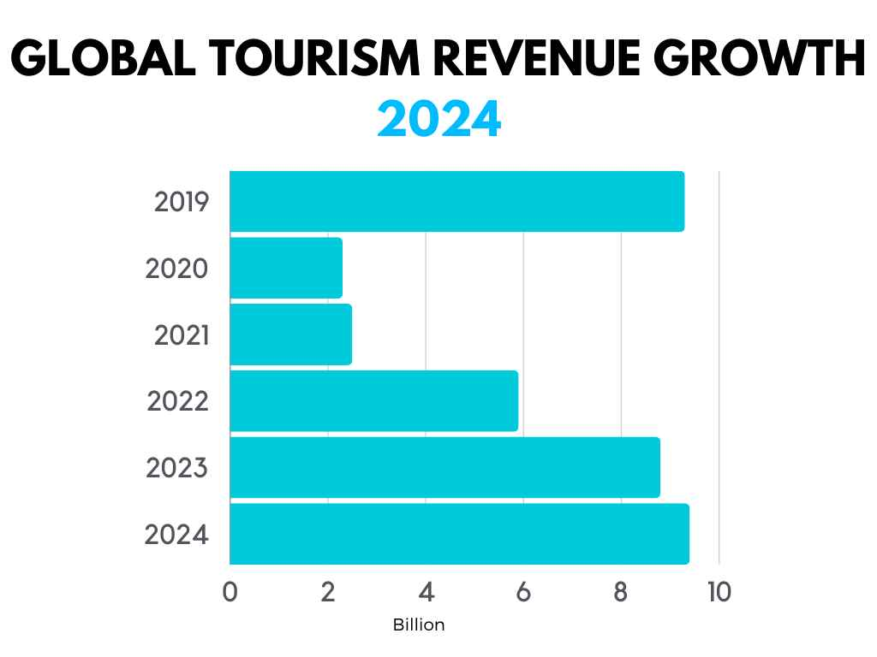 Fig 1.1 Revenue growth in tourism across recent years
of the regions in terms of art, history, festivals, and the local cus-toms. It not only makes the travelers get more interest in various types of cultures, but it also contributes to the economic development of the local communi-ties. Globalization has in these years created increased awakening, interest, and demand on genuine and memorable expe-riences by travelling. Due to this, the global tourism has now shifted out of the normal sightseeing to that of a cultural immersion tourism.

Digitization of tourism cannot be avoided and it is advancing hand in hand with the high growth in technology. Digital maps, social media, mobile applications, and online booking systems have been united in bringing a revolution to how trips are planned and experienced. The digital tools have actually contributed to boosting accessibility, efficiency and convenience among the travelers at every part of the world. Nevertheless, even with such innovations, most of the current tourism portal sites are preoccupied with the logistics of traveling such as hotel reservation and transport, as opposed to cultural richness and reality of the places they offer.
It is this gap, then, on which the present research is based, that the current systems of tourism largely ignore cultural richness and local involvement in their structures, that they constitute the core of the problem statement. Some of the apps such as TripAdvisor or MakeMyTrip are quite informative regarding the destinations and accommodation, however, lack in displaying regional customs, folklore, and local artisans or any community-oriented events that can be considered as the embodiments of the actual cultural image of a particular area.

Thus, the problem in the research is the gap in designing the system that would not only be a travel portal, but also provide the linking of the tour-ists with the people in the local communities. In this paper, it will be treated with the help of culture-based tourism development portal with the focus on immersion in culture, personalization, and commu-nity inclusion.

2. Literature Review
The three overall goals of the research are to promote and preserve cultural heritage, empower local artisans and com-munities, and to enhance the digital inno-vation in the tourism experience. The proposed system of
This is through virtual heritage tours or listing of any kind of cultural events where they match the seekers of culture giving them new suggestions relevant to themselves according to what is of interest to them.
This will be a worthwhile research, not only in creating sustainable tourism but also the development of the community. The project connects the technologic with the cultural preservation that not only allows implementing the economic improvement of the communities but also ensures that the traditions and cultural values should be transferred to the subsequent generations. It actually builds upon an integrative, more participatory, significant model of tourism that is conducive to both the travellers and the hosts.

The study literature review contextualizes the role of tech-nology, cultural insight into the role of digital innovation in the process of creating the modern tourist experiences. Taken as a whole, these documents indicate a new, although developing, trend in cultural tourism of providing authentic and involving experiences by the use of smart, user-focused platforms.

The cultural tourism development is evolving because of changes in technology and society.

The article by Richards 2018 deals with recent studies and tendencies in the new na-ture of tourism in the cultural sphere. He discusses the transformation of traditional tourism founded on heritage into active forms of tourism where an active participation on the part of the tourist exists with the local community. It is postulated that access will be enhanced and co-creation will contribute more- collectively the tourist influences his or her experience. But this is too a mere conceptual study, and there are no computer and analytical revelations made.
Limit: The study has a substantial theoretical foundation but does not incorporate or take into account contemporary data-driven methods or tools of artificial intelligence that can bring a significant contribution to the sphere of personalization of cultural tourism.

Urry and Larsen in The Tourist Gaze 3.0 discuss another significant sociology view regarding how culture and media construct the manner in which individuals comprehend places (2011). They present the concept that tourism is not just a visiting of a particular place but a way, specifically how culture is con-sumed with the eyes of the travelling person. Their writing provides an insight into the effect of gl-globalization on the experience of the tourist.
A primary drawback is that, despite being extremely powerful, it fails to elaborate on how the new technologies can transform the tourist gaze to suit this digital age. The absence of computational modeling further lessens its use in the technology-based tourism research.

2.2 Digitalization of the tourism industry.

Smith and Robinson (2019) conducted research in the article "Cultural Tourism in a Digital World" to examine the transformations that had occurred in the tourism experiences in the backdrop of swift advancement of digital tools and digital platforms. These types of online platforms have been found to make accessibility more accessible and enable successful promotion and the generation of user created cultural content. The authors pay attention to the fact that user-oriented design of the digital interfaces should be at the heart of the process of proving users engagement and cultural learning.
This work recognizes the possibilities and potentials of dig-ital technologies; simultaneously, the concerns about the problem of privacy and overdependence on the online environment exist. It does not, in particular, explore how artificial intelligence or ad-vanced analytics could be employed with the aim of maximizing the benefits of digital cultural experiences.

2.3 Behavioral and Technology design in Tourism.

Tussyadiah (2018) discusses the influence of tech-nology on the decision-making and travel behavior in the presentation titled Technology and Behavioral De-sign in Tourism Experience. The pa-per presents the major concepts of behavioral design that contribute to the efficiency and personalization on the side of the users. It describes the use of immersive systems in order to make cultural tourism more interesting.
Among the drawbacks is the fact that, despite the success of the study to associate technology and psychology, it has been unable to extend the study to the ex-ploration of adaptive or intelligent systems that might learn dy-namically the tastes of the users. Privacy risks and user mistakes by over- relying on technology are other limitations observed.

2.4 Recommender Systems AI and Hybrid.

The article A Hybrid Recom-mender System for Cultural Points of Interest by Chalkiadakis et al. (2023) tells about how AI can provide cultural recommendations. This hybrid will combine the Bayesian learning with content-based filtering, as it will give the specifics and variety to the tourists in the proposed recommendations of the cultural locations. This system ensures that the user has greater customization and access to a system that seeks an engaging cultural experience.
Good as the model is, it has certain chal-lenges in the respect of data bias and the problem of user trust. It is not transparent because of the complexi-ty, therefore, it is very dependent on sensitive user preference data, which is a cause of privacy concerns.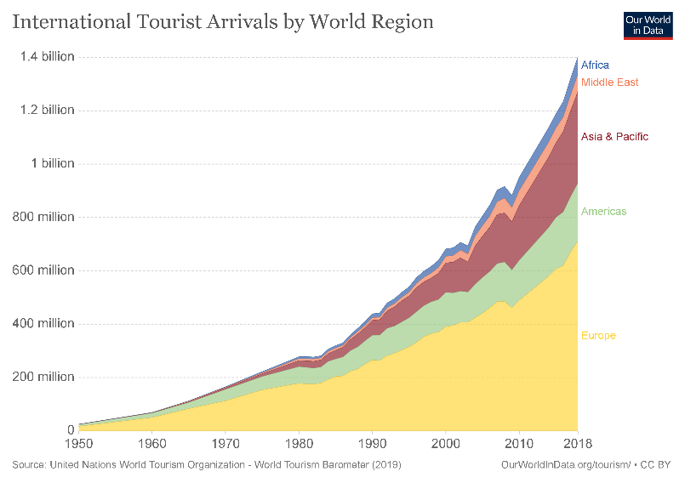

Fig 2.1 Tourist arrivals throughout the world

In Immersive Tourism, integrating VR/AR is beneficial since it enhances tourist experiences while offering new travel experiences and perceptions that render a specific location interesting to explore.

2.5 VR/AR in Immersive Tourism

VR/AR can positively contribute to the Immersive Tourism as it provides both the enhancement of tourist experiences and the introduction of new experiences and impressions that make a particular place to visit interesting.

The article by Yin et al. (2024) is called Exploring Virtual Attributes to Cul-tural Learning through VR/AR Heritage Tourism and examines the possibilities of using VR/AR in heritage tourism to facilitate cultural learning using virtual attributes. This piece has succeeded in showing how heritage sites can be virtually experienced virtually to even be viewed remotely with VR/AR. This can actually enhance cultural learning and inclusivity as one can access it anywhere in the world.
Limitation: Some of these challenges have been enumerated here in and they are; device dependency, high cost, and issues relating to authentici-ty. It also identifies data bias and privacy issues in the VR/AR systems particularly in user movement data collections, or user behavioral data collections.

2.6 Community based tourism platforms.

This article, Intelligent Digital Platform for Community-Based Tourism in Peru, was written by Maquera et al. in 2022 and presents a system that would be beneficial to the evolution of local communities around the tourism in the rural setting on the basis of a comprehensive digital platform. The use of such architecture links SMEs, guides, and tourists so that local actors can be seen and accessed more easily.
Limit: Although the system is more efficient and inclusive, it does not offer the personalization of the system that is based on AI, as well as multi-linguistic support. Questions of privacy and data accuracy are also issues that can be noted in this study that restrain scalability to larger implementations of this study across the world.

3. Problem Definition
Through online tourism websites such as TripAdvisor, MakeMyTrip and Booking.com, it has been quite easy in the digital world today to browse, plan and book travel experiences. The convenience factor introduced by these websites pertains to the process of making a reservation of accommodation, travel packages, and so forth, therefore, assisting customers in evaluating destinations. Even though this is gaining accessibility, making more destinations affordable throughout the globe, it still has one significant weakness the absence of promotion of the local culture and the involvement of the community.

Most of the tourism portals existing today are of a commercialistic nature and are not locally oriented in terms of culture. These are the high profile tourist destinations, and high quality experiences, rather than the richness of the cultural heritage, traditions, art forms, and events of the people that make a destination identity in the former. This ultimately comes out as tourists hardly having any significant form of local customs, craftsmen or cultures. Ultimately, these aspects lead to the surface knowledge about locations and the diminishment of true appreciation of cultures.

The other similar limitation that is a major limitation is the limited personalization of experiences. The current approaches provide generic travel recommendations with regard to localities or rating, but they do not capitalize on cultural interests and preferences of a person. A one-size-fits-all strategy would also fail in creating rich, passionate and unique travel experiences to the current culturally inquisitive traveler.

In addition, local artists, entertainers, and neighborhood organizations lack the resources to establish a channel to forge digital presence and marketing solutions into the minds of tourists. These small-scale stakeholders are the ones who hold precious information relating to culture and craftsmanship but are not connected to the global tourism networks. Their chances of succeeding in the economy and their cultural practices are limited without a proper digital representation since they may end up being erased with time.

This is why there is a great demand to possess one cultural based ecosystem in tourism to bridge technology and tradition. It must incorporate cultural information, involvement of a local community and smart recommendation systems that can provide tourists with unique authentic experience as well as empowering the local communities.

To counter such, the current research is coming up with the Culture-Based Tourism Development Portal, which will be an online platform where the cultural heritage will be digitized to protect it, with the locals involved to secure the sustainability of tourism. This portal uses culture not as a supplement, but as a starting point, and it renders tourism inclusive, interactive and community based.

4. Objectives

The general objective of the study is to design and develop a Cul-ture-Based Tourism Development Portal by incorporating cultural heritage and contemporary digital technologies to help in offering meaningful and sustainable tourism experiences. The following are the primary purposes that will be used in this study:

Actual cultural interaction through the digital devices.
These include offering options to the tourists to enjoy the destination using their cultural identities like festivals, folklore and food even to arts and traditional features using an interactive digital platform.

Protecting and enhancing local traditions, folk arts and culture.
The goal is to record and offer a distinctive cultural practice of various groups in the digital platform with a prospect to generate, preserve, and avail traditional arts, crafts, and heritage locations to an international community.
This will establish a platform that links the tourists and locals with the tourism boards. It is an online ecosystem that gathers together travelers with local artisans, guides, cultural organizations and tourism authorities to work together and raise visibility and growth.

5. Methodology / System Design
Make individual cultural recommendations possible:
Having such intelligent recommendation functionality, the system would comprehend the cultural prefe-rences of users and tailor such to their requirements so that places, events, and activities they like can be discovered.

Empower sustainable development of inclusive tourism.
We hope to impact the responsible tourism activities positively to the visitor and the local communities by means of economic in-clusion, cultural appreciation and long term sustainability.

Methodology / System Design
The Portal to the Development of Culture-Based Tourism will be structured systematically and modulatively to make it features scalable, efficient and attractive. The three-layer architecture that will be deployed in the system comprises of a frontend, backend and data layer. All the levels will perform specific tasks and assure the integrated and flowed user experience.

5.1 Architecture Overview

The three tier architecture is in harmony with the system and users where the presentation is highly isolated of the logic and the management of the data.
Frontend Layer:
This interface is the one that will engage the tourists, the artisans and administrators. It has been developed with the latest technologies, which include HTML5, CSS3, and JavaScript, as well as the use of Bootstrap to ensure that it is responsive to provide a superb user experience on the devices.
Backend Layer:
It comprises logic, data processing and two-way communication between the UI and the database of the application. The back-end is developed in PHP, on XAMPP Apache server, and it is used on different activities connected with user authenti-cation, some algorithms concerning recommendations, event management, etc.
Database Layer:
The MySQL database receives system-related information, such as, user profiles, cultural events, heritage facts, the list of artisans and feedback. The database structure is uniform, uncompromised and guarantees effectiveness in real-time operation processing.

5.2 Technology Stack

There are a number of tools and technologies which are extended to enhance functionality and performance of the portal.
Frontend: JS, CSS3, HTML5, Bootstrap.
PHP (XAMPP - Apache server) Backend.
Database: MySQL
APIs: Google Maps API to use in matters relating to the location, Event APIs that will give real-time information about cultural events.
git Source code management and collaboration.
An integration of technologies, which ensure flexibility, easy maintenance, and scalability to enhance it in the future.

6. Results and Discussion
CBTDP is already being put in place with encouraging outcomes, including the establishment of a cultural sensitivity, enhancement of user experiences, and adjustments between technology and tradition. The out-comes herein illustrate well how a digital system can transform cul-tural tourism into active and interactive as opposed to passive and becomes a community-based endeavor.

6.1 Learning Objectives

It was made in such a way that it was aimed at enhancing access, personalization, and engagement within the tourism ecosystem. The results are as follows:
Increased Accessibility:
The tourists will now be able to explore and navigate the cultural spots, events of the locality, and heritage sites of the destination in any corner of the world using just a single digital plat-form. Besides the advantages posed by built-in features, such as Google Maps, virtual heritage tours allow cultural tourism among people who cannot physically access the locations under discussion.
Personalization improved:
This is because the events and activities which the Recommendation Engine plans are tailored, in the field of the culture, based on the liking of each user. In fact, each one is unique. This will assist the user in identifying destinations that best almost match their cultural interests as opposed to generic travel choices.
Stronger Engagement:
Additional modules will also be introduced and they will be even more interactive like event listing, artist showcases, and vir-tual 360 tours. These will capture the users more as they will increase the interaction with the cultural content. At this point of involvement, the additional appreciation may be evoked and the further insight into the various traditions may be promoted.

6.2Comparison with the available tourism sites.

The entire strategy that the proposed system will pursue will be different than the prominent platforms like TripAdvisor or MakeMy-Trip in providing cultural immersion as opposed to travel logistics.
CBTDP is already being put in place with encouraging outcomes, including the establishment of a cultural sensitivity, enhancement of user experiences, and adjustments between technology and tradition. The out-comes herein illustrate well how a digital system can transform cul-tural tourism into active and interactive as opposed to passive and becomes a community-based endeavor.

6.3 Learning Objectives
It was made in such a way that it was aimed at enhancing access, personalization, and engagement within the tourism ecosystem. The results are as follows:
Increased Accessibility:
The tourists will now be able to explore and navigate the cultural spots, events of the locality, and heritage sites of the destination in any corner of the world using just a single digital plat-form. Besides the advantages posed by built-in features, such as Google Maps, virtual heritage tours allow cultural tourism among people who cannot physically access the locations under discussion.
Personalization improved:
This is because the events and activities which the Recommendation Engine plans are tailored, in the field of the culture, based on the liking of each user. In fact, each one is unique. This will assist the user to identify those destinations that suit their culture interests as opposed to generic travel.
Feature, | Existing Platforms, | Proposed Portal
Focus Area | Travel booking and reviews | Cultural exploration and engagement
Personalization | Based on ratings and popularity | Based on user’s cultural interests
Community Involvement | Minimal | High – includes local artisans and organizers
Accessibility | Primarily commercial destinations | Includes rural and community-based attractions
Cultural Preservation | Limited | Strong emphasis on heritage, art, and local traditions
This comparison highlights that the new system not only enhances user experience but also contributes to sustainable tourism by directly involving local communities and artisans in the tourism value chain.

Overview

Above all, the Culture-Based Tourism Development Portal is a promising step toward an inclusive and culturally enriching tourism ecosystem. It could be a strong point in culture preservation, community participation, and user personalization. For it to be globally impactful, with sustainability in the coming years, the site needs to overcome such current drawbacks that touch on AI integration, data privacy, and accessibility issues.

References
- Richards, G.: Cultural Tourism: A Review of Recent Research and Trends. Journal of Hospitality and Tourism Management, 36, 12–21 (2018).
- Smith, M., Robinson, L.: Cultural Tourism in a Digital World. Tourism Review, 74(3), 482–496 (2019).
- Urry, J., Larsen, J.: The Tourist Gaze 3.0. Sage Publications, London (2011).
- Tussyadiah, B.: Technology and Behavioral Design in Tourism Experience. Information Technology & Tourism, 19, 1–2 (2018).
- Maquera, J., et al.: Intelligent Digital Platform for Community-Based Tourism in Peru. Procedia Computer Science, 215, 731–740 (2022).
- Chalkiadakis, I., et al.: A Hybrid Recommender System for Cultural Points of Interest. Springer Nature Computer Science, 4, 65–78 (2023).
- Yin, H., et al.: Exploring Virtual Attributes for Cultural Learning through VR/AR Heritage Tourism. Computers in Human Behavior Reports, 12, 101315 (2024).
- Tang, R., et al.: Research on Digital Transformation Driving the High-Quality Development of Cultural and Tourism Enterprises. Journal of Open Innovation: Technology, Market, and Complexity, Springer, 10(1), 15–28 (2024).
- Solano-Barliza, A., Arregocés-Julio, I., Aarón-Gonzálvez, M., Zamora-Musa, R., De-La-Hoz-Franco, E., Escorcia-Gutierrez, J., Acosta-Coll, M.: Recommender Systems Applied to the Tourism Industry: A Literature Review. Cogent Business & Management, 11(1), 238–249 (2024).
- Sandriester, J., Harfst, J., Kern, C., Zuanni, C.: Digital Transformation in the Cultural Heritage Sector and Its Impacts on Sustainable Regional Development in Peripheral Regions. Sustainability, 17(15), 6661 (2025).
- Chengcai, T.: The Model and Path for Digital Cultural Tourism to Promote Rural Revitalization. Journal of Resources and Ecology, 15(3), 233–245 (2024).
- Meng, L., et al.: A Meaning-Aware Cultural Tourism Intelligent Navigation System. Sensors, 21(3), 845–858 (2021).
- Generosi, A., et al.: A Recommender-Based Web Platform to Boost Tourism in Inland Destinations and Networking Opportunities. Springer Nature Computer Science, 5(2), 24–39 (2025).
- Gasparetti, F., Micarelli, A., Sansonetti, G.: Tourism Recommender Systems as a Vehicle for Social Inclusion. CEUR Workshop Proceedings on Intelligent User Interfaces, Vol. 2903, 34–42 (2021).
- Cuomo, M.T., Tortora, D., Metallo, G.: Digital Transformation and Tourist Experience Co-Design: Opportunities and Challenges. Technological Forecasting and Social Change, 165, 120543 (2021).
- Arregocés-Julio, I., Solano-Barliza, A., Acosta-Coll, M.: A Flexible Profile-Based Recommender System for Cultural Tourism to Strengthen Emerging Destinations. Information (MDPI), 12(3), 81 (2025).

